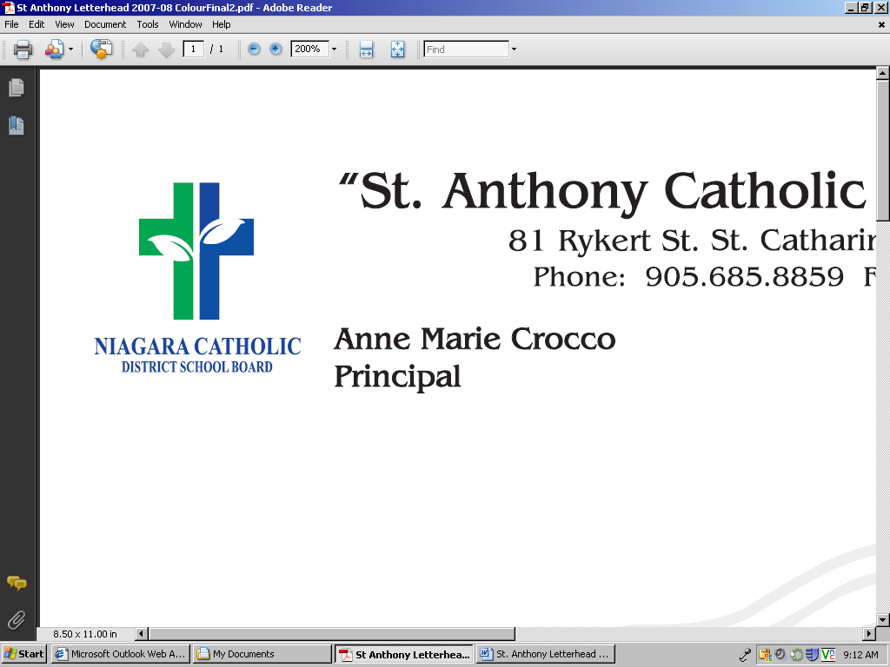

**Appendix A**

**VOLUNTEER APPLICATION FORM**

I _________________ wish to serve as a volunteer at __________________Catholic School.

As a volunteer I acknowledge and will adhere to the following expectations:

* As a school volunteer I shall serve under the immediate supervision and direction of administration and staff of the school.
* I will volunteer without remuneration.
* I understand that the Police Vulnerable Sector Check as well as all subsequent offence declarations provided by me, will be filed at the school.
* As a volunteer I will adhere to all Board Governance Policies and Administrative Operational Procedures at all times when volunteering for school and/or Board events or activities.
* As a volunteer driver, I will adhere to the [***Volunteer Drivers Administrative Operational Procedures (302.4)***](https://docushare.ncdsb.com/dsweb/Get/Document-1981975/302.4%20-%20Volunteer%20Drivers%20AOP.pdf)***.***
* I understand that classroom teachers and school administrators are solely responsible for student discipline, and will seek assistance if necessary.
* I understand that this agreement pertains to all school and off-site activities/events such as educational field trips as they are an extension of the school.
* I acknowledge that in the course of my volunteer work that confidential information with respect to the affairs of staff, students, parents/guardians, the school and/or the Board may be disclosed. I hereby agree not to disclose, at any time, such confidential information to any person.
* I have read and agree with the Volunteering in Catholic Schools Administrative Operational Procedures (800.9) and statements within the Volunteer Application Form.

*____________________________________ _____________________________________ Principal’s Signature Volunteer’s Signature*

*Date_____________________________ Date_______________________________*

*This information is collected under the authority of the Education Act and in compliance with the Municipal Freedom of Information and Protection of Privacy Act. Should you have questions, please contact the Principal of the school.*